13.55: a) The damping constant has the same units as force divided by speed, or 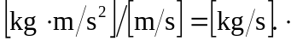 b)The units of 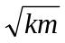 are the same as 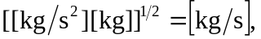
the same as those for
as shown in Fig.(13.27).

